Q.

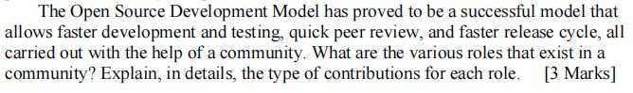

Q.

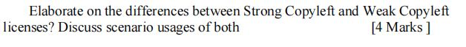

Q.

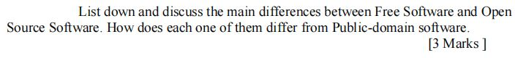

Q.

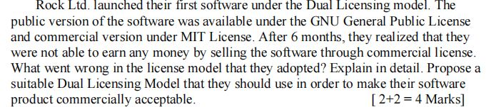

Q.

https://bitsmediarepo.blob.core.windows.net/questionmages/QuestionImages/0188000/QuestionImage_1694607426261.jpeg

Q.

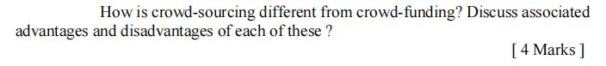

Q. 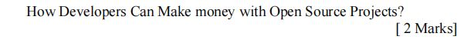

Q.

